2021 Canteen Survey
Sent to 115 registered members at the time within RevSport
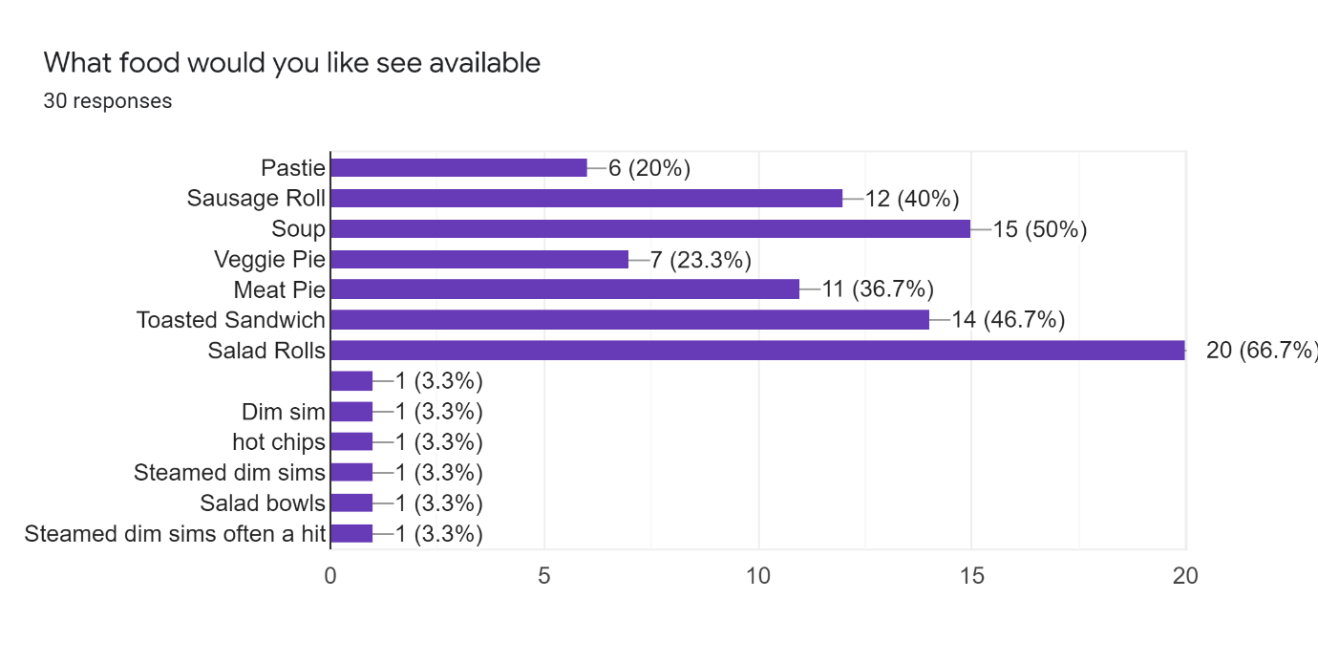
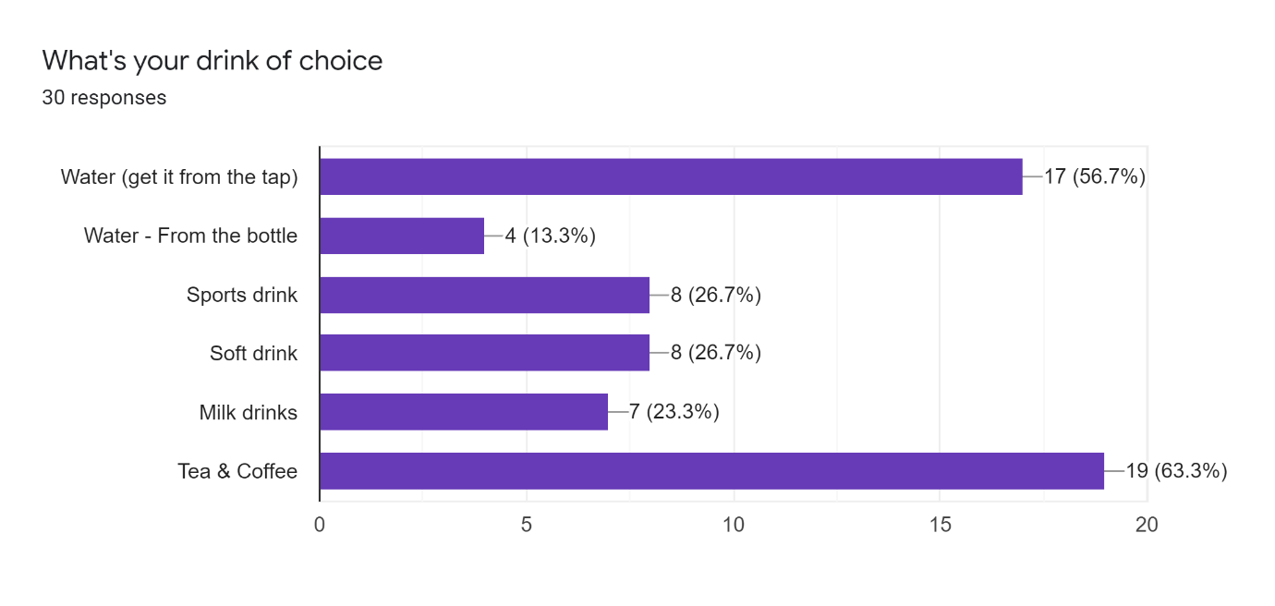
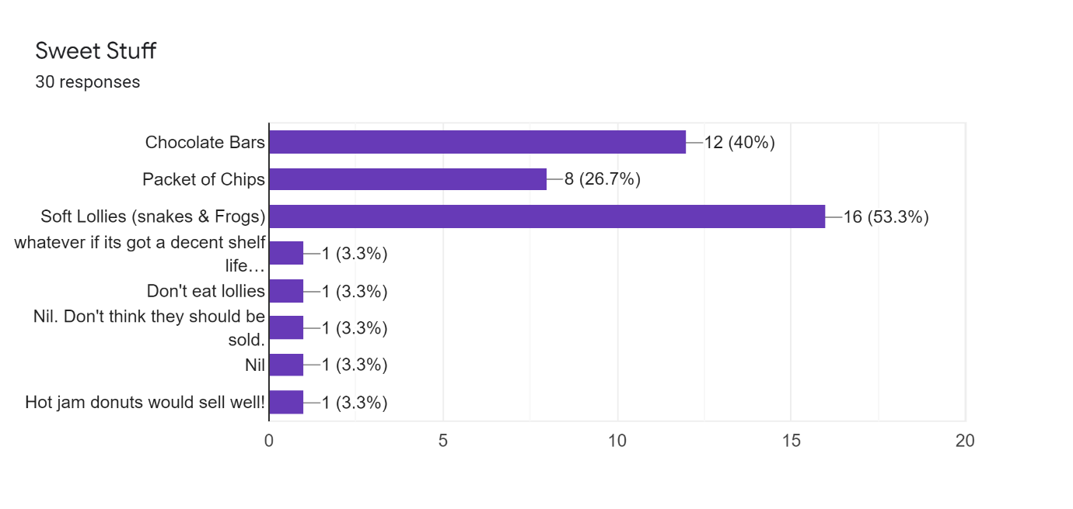
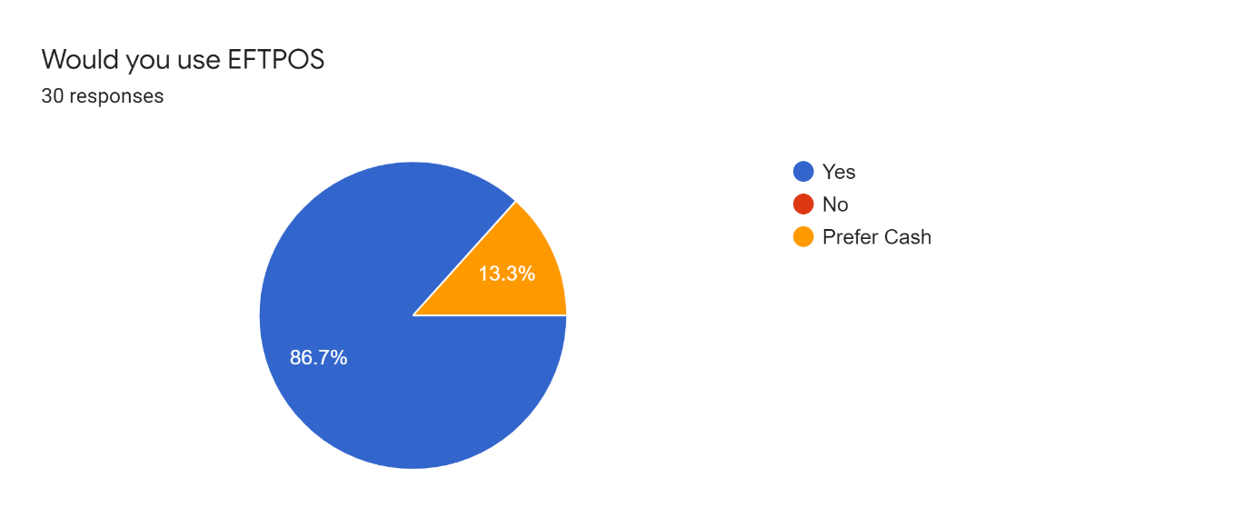

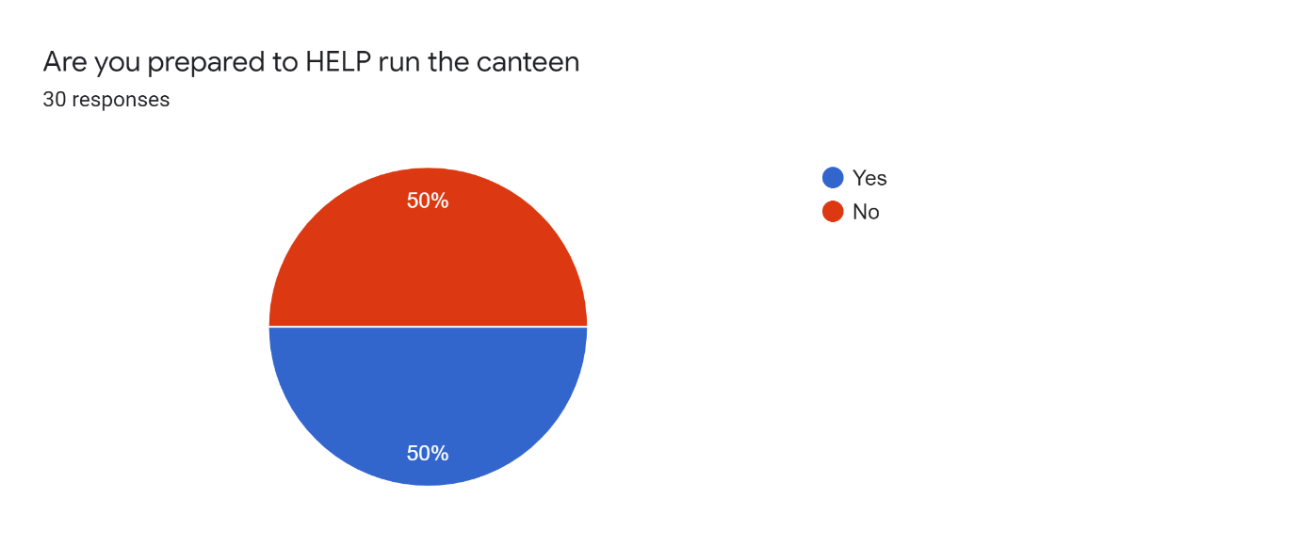

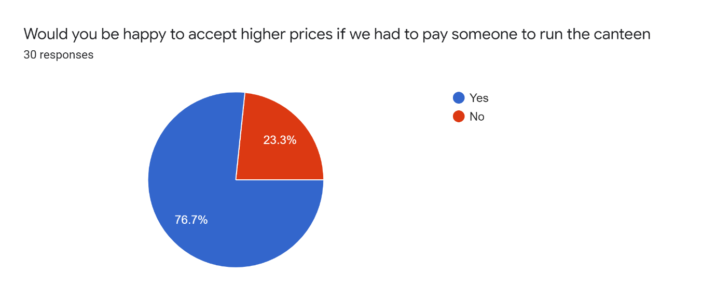

Is there something else would you like to see in the canteen or suggestions on our canteen operation?
- I would prefer vending machines
- think need to be a little health conscious, fruit salad cups?, pasta salads cups? especially if a person is paid to run/make stuff, spare mouth guards available to buy,
- Alcohol if done well can give a lot of positives financially , increasing supporter numbers and modelling responsible behaviour
- Happy to help out when I can
- Not really fussed if it's closed, unlikely to use often if at all
- Alcohol
- more variety of hot and cold food, the canteen has been the same way for over 20yrs need to update to keep with patronage of the venue keeping money in there rather than them going else where to bring food back in.
- Hedgehog
- I don't really use the canteen. While it's a great fundraiser for the association, I wouldn't miss it if we didn't have one. I think we need to figure out how many people actually use it and if it's worth running. It takes a lot of effort and organising for not much return. I would be lucky to have used it 3 times in the last 5years.
- Fruit.
- I do t like them, but when I have done a shift there I have sold lots of dim sims.
- A team roster system could work

